**REPORT**

**ON CAMPUS EXPERIENTIAL LEARNING PROGRAM (ELP)**

**[25/11/2022 TO 31/12/2022]**

**SUBMITTED TO**

**Training & Placement cell**

**SUBMITTED BY**

|  |  |  |  |
| --- | --- | --- | --- |
| **Samiran Biswas** | **Devansh Rathore** | **Vikas Mahla** | **Ulka Sarkar** |
| **Ved Kumar sudhanshu** | **Varsha Kumari** | **Anshika Rai** | **Aditya Kumar** |
| **Bhukya Vamshi Krishna** | **Sankha Nandi** | **Yogesh Sahu** | **Shashank Singh** |

**COLLEGE OF AGRICULTURAL ENGINEERING & TECHNOLOGY**

**DR. RAJENDRA PRASAD CENTRAL AGRICULTURAL UNIVERSITY,**

**[PUSA, SAMASTIPUR]**

**GUIDED BY**

**Er. Jaya sinhaABSTRACT**

**ELP [experiential learning program] is basically learning by earning program. In our 10 week ELP Program Of our 7th semester, we worked on farm mechanization & entrepreneurship development which benefited farmers and students both. Farm mechanization is the application of engineering and technology in agricultural operations, to do a job in a better way to improve productivity. The purpose of this paper is to describe operation of CHC. We started a custom hiring centre. CHC is basically a unit comprising a set of farm machinery, implements and equipment meant for custom hiring by farmers. We named our (CHC) as "Modern Machinery Rental Service". Role of custom hiring agro service in rural areas is very important and useful for farmers. We planned tours in nearby villages with established CHC & survey to understand the current trend and needs of farm mechanization. We evaluated and identified machineries for hire based on farmer demand, competition and availability. We collected all the data and prepare a list of important machinery & problems of farmers. After that we provided them with required machineries like Super-Seeder, Paddy thresher & Zero till-drill, which was very helpful for them & benefited them in many aspects. In our CHC we carried out all the operations step by step such as collecting the data of farmers, useful machineries, proper documentation, Daily cash record, Balance sheet etc. which followed all the Scheme, act and safety. This report also includes feedback of farmers after using our service. ACKNOWLEDGEMENT**

**Most humbly and respectfully, with all due attention it gives us an immense pleasure on completion of our on-campus 10 weeks ELP program in College Of Agricultural Engineering & Technology. We would like to express our sincere gratitude to dean of our college, Dr. Ambrish Kumar sir, Dr. S K Patel sir [FMPE, HOD] and our ELP coordinator Er. Sanjay Kumar sir. Special thanks is due to our ELP instructor Er. Jaya Sinha mam for whose help, stimulating suggestions and encouragement helped us in all time of fabrication process and in writing this report & conducting such an amazing, and full of practical knowledge-based ELP program in such a short period.**

**This report cannot be completed without the effort and co-operation of our group members- Anshika Rai, Varsha Kumari, Aditya Kumar, Ved Kumar sudhanshu, Samiran Biswas, Devansh Rathore, Ulka Sarkar, Vikas Mahla, Sankha Nandi, Bhukya Vamshi Krishna, Yogesh Sahu, and Shashank Singh.**

**We would also like to acknowledge with much appreciation the crucial role of the staff of our department specially Ram Naresh ji and Pinku ji.**

**Finally we apologise all other unnamed who helped us in various ways to have a good training in ELP.**

**TABLE OF CONTENT**

**INTRODUCTION** 6

FARM MECHANIZATION:- 6

Benefits of Farm Mechanization 6

Scope of Farm Mechanization 6

Different farm machineries manufacturers and their brands 6

AGRICULTURAL MACHINERY CUSTOM HIRING CENTRE 7

WHAT IS CUSTOM HIRING CENTRE? 7

Objectives 7

Potential for Custom Hiring Centres: 8

**ENTREPNEURSHIP ACTIVITIES** 9

IMPORTANCE OF ENTREPRENEURSHIP 9

Differences between entrepreneurship, self-employment and wage employment 9

Role of custom hiring agro service centres in development of rural areas and their important characteristics:- 10

Government policies for promotion of agricultural mechanization and agro service centres:- 10

Establishment of Farm Machinery Banks 11

**SETTING UP CUSTOMER HIRING CENTRES** 13

PLANNED TOURS TO LOCAL NEARLY VILLAGE WITH ESTABLISHED CUSTOM HIRING AND AGRO- SERVICE CENTRES 13

TESTING OF IMPLEMENTS AVAILABLE IN OUR CHC 13

LOCATION OF CHCs 13

LOCAL SURVEYS TO UNDERSTAND THE CURRENT TREND AND NEEDS OF FARM MECHANIZATION 14

NAMING AND TEMPLATE MAKING OF OUR CHC 17

FARMER’S VISIT TO OUR CHC 17

CALCULATION OF HIRING PRICES FOR THE MACHINERY 18

**OPERATION OF A SUSTAINABLE MODEL OF CHC** 20

SHOP AND ESTABLISHMENT ACT 20

INCOME TAX 21

LABOUR LAWS 21

Recruit workers as per the requirement. 21

Operation of CHC in a sustainable model:- 22

**DOCUMENTATION AND RECORD KEEPING OF CHC** 23

IMPORTANCE OF DOCUMENTATION:- 23

TYPES OF RECORDS:- 23

Maintenance of documents in a customer hiring centre:- 23

RECORD OF PERIODICAL MAINTENANCE OF MACHINERIES 24

DATABASE OF FARMERS ALONG WITH FREQUENCY OF VISIT 25

DAILY CASH RECORD 26

BALANCE SHEET: 27

FEEDBACK OF FARMERS 27

**MAINTAINANCE AND SAFETY AT WORKPLACE** 31

BASIC SAFETY CHECKS BEFORE OPERATION OF ALL MACHINERY & VEHICLES 31

PRECHECKING OF TRACTOR AND IMPLEMENTS 31

PROTECTIVE CLOTHING AND EQUIPMENT 32

HAZARDS MENTIONED ON THE LABELS OF PESTICIDES/ FUMIGANTS 32

OTHER REGULATIONS AT CHC:- 33

**CHAPTER NO. 1**

# INTRODUCTION

## FARM MECHANIZATION:-

Farm mechanization is the application of engineering and technology in agricultural operations, to do a job in a better way to improve productivity. This includes development application and management of all mechanical aids for field production, water control, material handling, storing and processing. Mechanical aids include hand tools, animal drawn equipment, power tillers, tractors, engines, electric motors, processing and hauling equipments.

### Benefits of Farm Mechanization

* Timeliness of operation
* Precision of operation
* Improvement of work environment
* Enhancement of safety
* Reduction of drudgery in farm operation
* Reduction of loss of crops and food products
* Increased productivity of land
* Increased economic return to farmer
* Improved dignity of farmer
* Progress and prosperity in rural areas

### Scope of Farm Mechanization

* Improved irrigation facility
* Introduction of high yielding varieties of seeds
* Introduction of high dose of fertilizers and pesticides for different crops
* Introduction of new crops in different parts of the country.
* Multi cropping system and intensive cultivation, followed in different parts of the country.

## Different farm machineries manufacturers and their brands

* Tractor:- Massey Ferguson, Mahindra, Sonalika, John Deere, Tafe, Holland.
* Superseeder:- Shaktiman, Dasmesh, Fieldking.
* Potato planter:- Mahindra, Shaktiman, Sonalika.
* Zero till-drill:- National Agro industries, Swan, Narmada.
* Paddy thresher:- Dasmesh, Surjeet, Panesar.

## AGRICULTURAL MACHINERY CUSTOM HIRING CENTRE

Mechanical power is largely consumed in big land holdings and is still beyond the reach of small/marginal holdings which constitute around 80% of the total land holdings. This is due to the fact that the small/ marginal farmers, by virtue of their economic condition are unable to own farm machinery on their own or through institutional credit. Therefore in order to bring farm machinery available within the reach of small holding, collective ownership or custom hiring centre needs to be promoted in a big way. This model scheme is prepared to demonstrate the banks that financing for establishment of custom hiring centre are a financial viable unit.

### WHAT IS CUSTOM HIRING CENTRE?

CHCs are basically a unit comprising a set of farm machinery, implements and equipment meant for custom hiring by farmers. Though certain implements and equipment are crop specific, the traction units like tractors, power tillers etc., and self-propelled machinery like combine harvesters etc., are used in common. Therefore, an ideal model envisaged in this project comprise farm machinery that are commonly used for tillage operations for all crops, multi crop equipment and a minimum of crop specific machinery.

* list of important machineries to be used on farm such as:-

1. Tractor/ power tiller
2. Land preparation equipment
3. Land levelling equipment for soil conservation work
4. Irrigation devices and equipment
5. Sowing and fertilizer equipment
6. Plant protection equipment
7. Harvesting/reaping equipment
8. Threshing/shelling equipment
9. Trolley for material handling

### Objectives

* To make available various farm machineries/equipments to small and marginal farmers.
* To offset the adverse economies of scale due to high cost of individual ownership To improve mechanization in places with low farm power availability
* To provide hiring services for various agricultural machinery/ implements applied for different operations.
* To expand mechanized activities during cropping seasons in large areas especially in small and marginal holdings.
* To provide hiring services for various high value crop specific machines applied for different operations.

### Potential for Custom Hiring Centres:

* As the small/marginal holdings constitutes 80% of total land holdings, the potential for CHC which will cater to the farm machinery requirement of such a vast area, is quite huge.
* Government of India, in recognition of this potential has envisaged increase of farm power availability from the present level (0.93 to 2kw/ha) during the 12th plan period. The Sub Mission on Agricultural Machinery (SMAM) is one such initiative towards the objective.
* Subsidy schemes are also being formulated to encourage entrepreneurs and agri graduates to set up custom hiring centres.
* Therefore, keeping in view the emphasis of agricultural farm machinery and the need for taking the of farm machinery within the reach of small/ marginal farmers, institutional credit needs to be made available for CHCs.

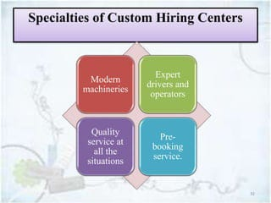

**CHAPTER NO. 2**

# ENTREPNEURSHIP ACTIVITIES

## IMPORTANCE OF ENTREPRENEURSHIP

* Creation of job opportunities.
* Impact on community development.
* The consequence of business failure.
* Political and economic integration of outsiders.
* Spawns entrepreneurship.
* Enhances the standard of living.
* Promotes research and development.

### Differences between entrepreneurship, self-employment and wage employment

Entrepreneurship and self-employment easily can be confused, but there are distinct differences in the definitions of these terms. Self-employed individuals perform services on a contract basis for a range of clients. Entrepreneurs organize productive assets to create and maintain a business. Self-employed individuals are not technically entrepreneurs. Both terms generally refer to the act of taking your financial situation into your own hands, rather than relying on an employer for income.

Self-Employment:-Self-employed is a situation in which an individual works for himself instead of working for an employer that pays a salary or a wage.

**Advantage**

* You can set your own hours.
* Don't need educational degrees or certificates.
* can make your own decisions.

**Disadvantage**

* You have to work many hours each day to make any money.
* Business income varies, but business expenses are more constant (e.g., utilities, supplies, marketing).
* You usually need capital to get started.
* Responsibility for business success is stressful.

Wage Employment:-Some people work as a salaried employee earning a set amount of money each week.

**Advantage**

* You receive wages on a regular basis.
* You can have opportunities for promotion.
* Social contact with co-workers.
* Less stressful, you can leave your work behind at the end of the day.

**Disadvantage**

* You cannot set your own schedule.
* Your work hours may not be convenient for you.
* You have no control over work conditions.
* You have limited opportunities to make decisions.

### Role of custom hiring agro service centres in development of rural areas and their important characteristics:-

* Provides access to small farmers to costly farm machinery.
* Reduces drudgery.
* Reduction in cost of cultivation.
* Work opportunities to skilled labour.
* Increase in cropping intensity wherever feasible.
* Efficiency in use of resources and applied inputs.
* Crop diversification.
* Timely production.
* Provides farm advisories.

### Government policies for promotion of agricultural mechanization and agro service centres:-

The Ministry of Farmers Welfare, Government of India, has initiated the implementation of the approved the Agricultural Mechanization Promotion Scheme with the primary objective of reducing air pollution caused by stubble burning. One of the primary reasons behind this is said to be the burning of crop residue by farmers. Due to this, numerous other cities and villages are suffering the evil pangs of pollution and contamination of the air. Thus, in order to nullify this and control pollution, the Central Government of India is launching Agricultural Mechanization Promotion Scheme 2018-2019.

#### The Budget

The Central Government of India has estimated to spend nearly INR 1151.80 Crores within the financial years of 2018-2019 and 2019-2020 towards this scheme – which is expected to be split into INR 591.65 Crores and INR 560.15 Crores respectively.

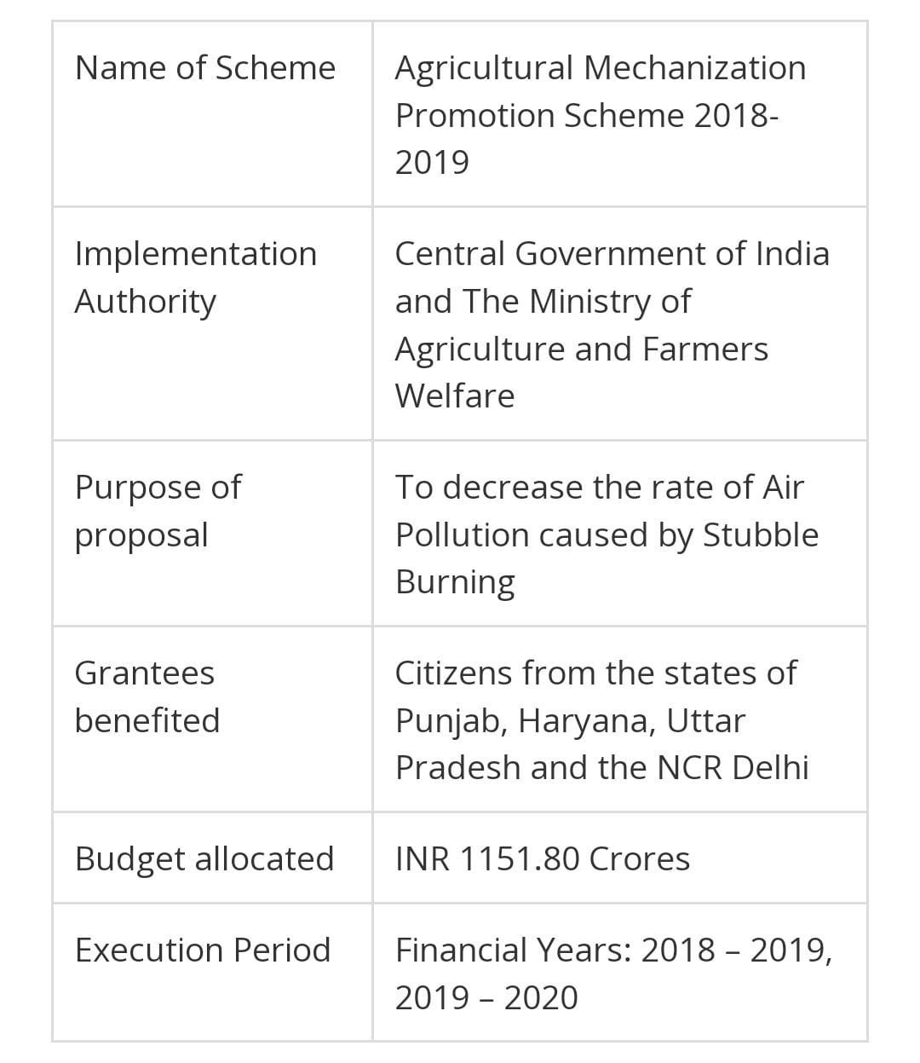

### Establishment of Farm Machinery Banks

With the help of Agricultural Mechanization Promotion Scheme, the farmers can easily hire the in-situ crop residue management machinery through which the Government is hoping to reduce air pollution caused by the agricultural sectors. Apart from this, the Scheme also ensures financial assistance of up to 80 per cent to various Farmers Societies, Farmer Producer Organization Scheme (FPOS), Self-Help Groups, Women Farmer Groups, etc.

#### Financial Aid to Farmers

Apart from the benefits mentioned above, additional financial aid of 50 per cent is rendered to the farmers to help them purchase agricultural machinery and other types of equipment for Crop Residue Management. Thus, by providing such remarkable benefits, the Government believes that the outcome of Agricultural Mechanization Promotion Scheme will definitely reduce Stubble Burning and thereby reduce air pollution.

#### Education, Information and Communication

On the context of Agricultural Mechanization Promotion Scheme, the Central Government of India provides some financial support to the Concerned State Government along with the Krishi Vigyan Kendras (KVKs). Such Kendras include an agricultural extension centre in India, ICAR – Central Island Agricultural Research Institutes, Central Government Institutes and Public Sector Undertakings. Besides this, the Government of India is hoping to continue this awareness by organising many campaigns through films, documentaries, radio and TV programmes, advertisement in print media, Camps, etc. for achieving Zero Stubble Burning.

#### Beneficiaries of this Scheme

* Corresponding State Governments will identify various recipients through District Level Executive Committee (DLEC) for the establishment of farm machinery bank.
* It can also be utilized for Custom Hiring of products and procurement of Machines on individual ownership basis in order to avail the benefits in a transparent and time-bound manner.
* The State Nodal Department ties up with the Local Banks to credit financial aid towards the requirements of the farmers.
* And finally, name and details of selected beneficiaries will be documented at district level indicating Aadhar/UID numbers, and the financial assistance is expected to be paid through District Benefit Transfer (DBT).

**CHAPTER NO. 3**

# SETTING UP CUSTOMER HIRING CENTRES

## PLANNED TOURS TO LOCAL NEARLY VILLAGE WITH ESTABLISHED CUSTOM HIRING AND AGRO- SERVICE CENTRES

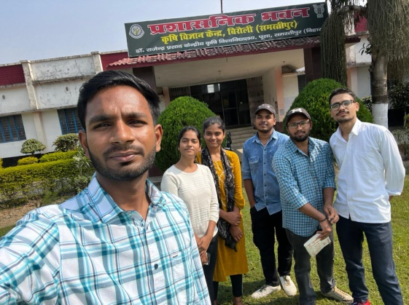On the first day of our work, we visited **krishi vigyan Kendra** (**KVK**), Birauli to get information about established custom hiring centre and their rates of machine use.

## TESTING OF IMPLEMENTS AVAILABLE IN OUR CHC

Figure 1:- Survey in KVK

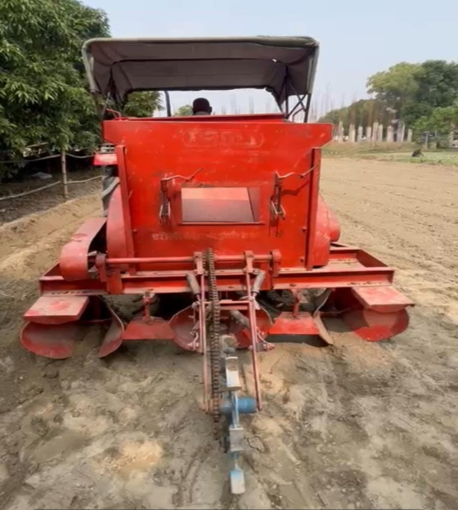 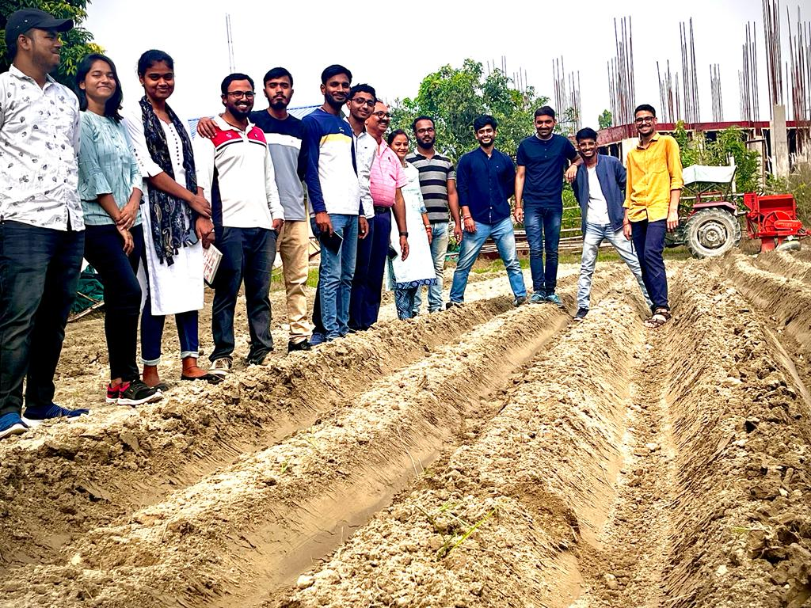

Figure 2:- Testing of potato planter in our college

## LOCATION OF CHCs

Ideally, the CHC shall have to be located in a place where by and large small land holdings are located within a radius of 5 to 7kms. This will reduce the transport cost and time of transport of agricultural machinery. In other terms, one CHC is expected to cater to 4/5 villages and therefore a common place equidistant from the villages catered is advisable. Factors for selecting the location such as availability of basic utilities like- water, electricity accessibility to farms, farmer’s homes.

## LOCAL SURVEYS TO UNDERSTAND THE CURRENT TREND AND NEEDS OF FARM MECHANIZATION

* On the first week of our work, we visited several farmers from nearby villages (Parna, Bakhri, Harpur, Gorai, Birauli).
* We carried out local surveys to understand the current trend and needs of farm machineries.

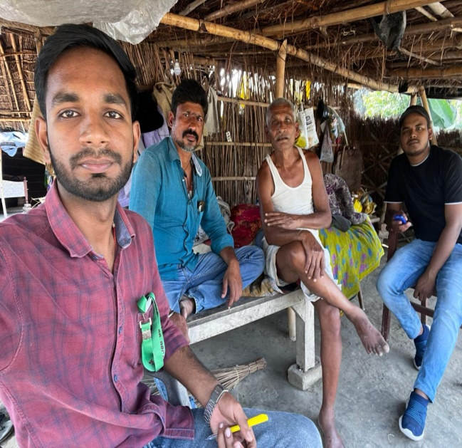 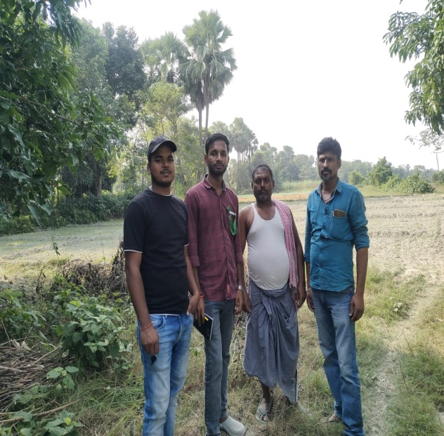

Figure 3:- local survey in villages

* We enlisted their details like: (name, contact no., village, crop, field area, machineries required).

|  |  |  |  |
| --- | --- | --- | --- |
| **FARMER’S NAME** | **AREA (ACRES)** | **CROP** | **IMPLEMENTS REQUIRED** |
| Dayashankar | 2.5 | Paddy, Wheat | Reaper, Superseeder |
| Divyanshu | 0.5 | Paddy, Wheat | Reaper, Superseeder |
| Avneesh kumar pandey | 3 | Paddy, Wheat | Reaper, Superseeder |
| Ramashish das | 1 | Wheat, Paddy, Potato | Reaper, Superseeder, Potato planter |
| Mukesh kumar choudhary | 0.7 | Wheat, Paddy, Potato | Reaper, Superseeder, Potato planter |

Table 1:-village of survey - Parna

Table 2:- Village of survey - Bakhri

|  |  |  |  |
| --- | --- | --- | --- |
| **FARMER'S NAME** | **AREA (ACRES)** | **CROP** | **IMPLEMENTS REQUIRED** |
| Pashupati Pandey | 10 | Paddy, Wheat | Reaper, Superseeder, DSR |
| Jagdish Pandey | 3.5 | Paddy,Wheat, Haldi | Reaper, Superseeder, DSR |
| Sanjay kumar pandey | 3.5 | Paddy, Wheat, Potato, Maize | Reaper, Superseeder,Potato planter, DSR |
| Parshuram pandey | 5 | paddy, Wheat, Turmeric | Reaper, Superseeder, DSR |
| Harishankar pandey | 3.5 | Paddy, wheat, Potato, Maize | Reaper, Superseeder, DSR |
| Kamseshwar rai | 4 | paddy,wheat,turmeric | Reaper, Superseeder, DSR |
| Dhaneshwar rai | 4 | Paddy, Wheat, Maize, Potato, Turmeric | Reaper, Superseeder, Potato planter, DSR |
| Baidhyanath rai | 4 | Paddy, Wheat, Maize, Potato, Turmeric | Reaper, Superseeder, Potato planter, DSR |
| Lalan kumar pandey | 4 | Paddy, Wheat, Maize, Potato, Turmeric | Reaper, Superseeder, Potato planter, DSR |
| Suman kumar pandey | 4.5 | Paddy, Wheat, Maize, Potato, Turmeric | Reaper, Superseeder, Potato planter, DSR |
| Awadesh prasad singh | 3 | Paddy, Wheat, Maize, Potato, Turmeric | Reaper, Superseeder, Potato planter, DSR |
| Kailash singh | 3 | Paddy, Wheat, Maize, Potato, Turmeric | Reaper, Superseeder, Potato planter, DSR |
| Ramprasad mahto | 2.75 | Paddy, Wheat, Maize, Potato, Turmeric | Reaper, Superseeder, Potato planter, DSR |
| Shayama panday | 3 | Paddy, Wheat, Maize, Potato, Turmeric | Reaper, Superseeder, Potato planter, DSR |
| Vinay kumar pandey | 2.75 | Paddy, Wheat, Maize, Potato, Turmeric | Reaper, Superseeder, Potato planter, DSR |
| Shivsagar pandey | 4.5 | Paddy, Wheat, Maize, Potato, Turmeric | Reaper, Superseeder, Potato planter, DSR |
| Chandeshwar pandey | 4.25 | Paddy, Wheat, Maize, Potato, Turmeric | Reaper, Superseeder, Potato planter, DSR |
| Sunil kumar pandey | 3.5 | Paddy, Wheat, Maize, Potato, Turmeric | Reaper, Superseeder, Potato planter, DSR |
| Sudhir kumar pandey | 5 | Mango, Litchi, Lemon | Gardening tools |
| Naval prasad singh | 30 | Mango, Litchi, Lemon | Gardening tools |
| Ranjeet prasad singh | 9 | Mango, Litchi, Lemon | Gardening tools |
| Shashi bhusahna pandey | 9 | Mango, Litchi, Lemon | Gardening tools |

|  |  |  |  |  |
| --- | --- | --- | --- | --- |
| **FARMER’S NAME** | **AREA (ACRES)** | **CROP** | **IMPLEMENTS REQUIRED** | |
| Rajeev kumar | 2 | Wheat, Potato | | Reaper, Superseeder |
| Shivam kumar trivedi | 5 | Wheat, Potato | | Reaper, Superseeder |
| Binod kumar sah | 2 | Paddy, Wheat, Potato | | Reaper, Superseeder, Potato planter |
| Jageshwar sah | 3 | Paddy, Wheat, Potato | | Reaper, Superseeder, Potato planter |
| Dinesh rai | 1 | Paddy, Wheat, Potato | | Reaper, Superseeder, Potato planter |
| Ganga sah | 1 | Paddy, Wheat | | Reaper, Superseeder |
| Bhupaneshwar sah | 1 | Paddy, Wheat | | Reaper, Superseeder |
| Ramdayal rai | 2 | Paddy, Wheat | | Reaper, Superseeder |
| Ramkripal rai | 1 | Paddy, Wheat | | Reaper, Superseeder |

Table 3:- village of survey - Harpur

* We evaluated and identified machineries for hire based on farmer demand, competition and availability.
* We prepared a list of machineries needed by farmers and available to us.

|  |  |  |  |
| --- | --- | --- | --- |
| **Name of implement** | **Requirement of farmers** | **Availability in our CHC** | **Defect in our implement** |
| Potato planter |  | × | Inaccurate plant spacing and seed rate. |
| Super seeder |  |  | - |
| Zero till- drill |  |  | - |
| Reaper cum binder |  | × | Damaged |
| Paddy thresher |  |  | Inappropriate speed reduction unit, (speed higher than required) |
| Multi-crop planter | × |  | - |
| Tractor (60 hp) |  |  | - |
| Tractor (35 hp) |  |  | - |

## NAMING AND TEMPLATE MAKING OF OUR CHC

* We decided a brand name for our hiring service as “Modern machinery rental service”.
* Then, prepared an application form to be filled by farmers if they need our services.

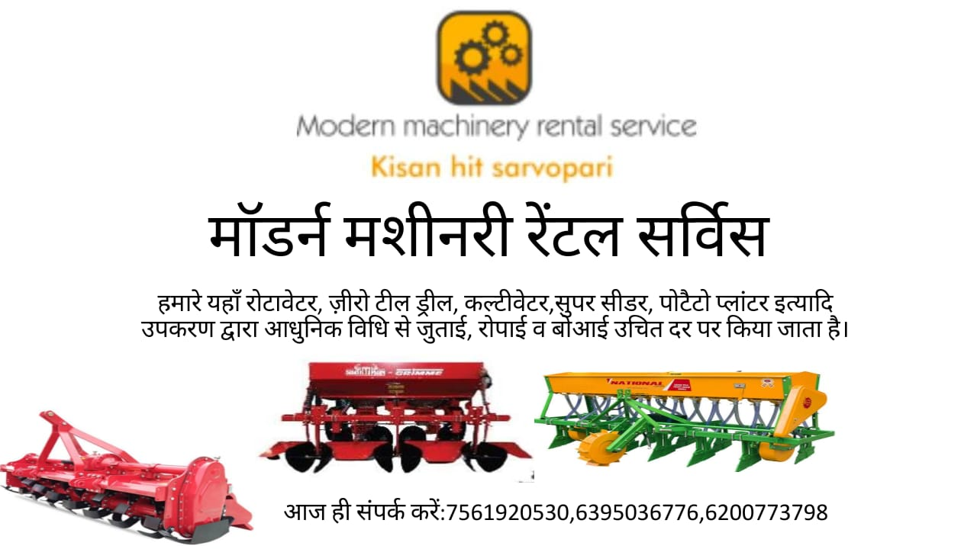

* Then we started advertisement of our CHC by giving them our template and application form.
* If they needed our services, they contacted us through phone calls.

## FARMER’S VISIT TO OUR CHC

* We offered farmers that they can visit our CHC and check our machineries.
* Whenever they visited, we explained them about our services demonstrated our machineries.
* If they needed our machine, they filled up the application form and after approval by HOD and ELP co-ordinator, we started taking our tractor and implements to farmer’s field.
* We also maintained database of farmers along with frequency of visit.

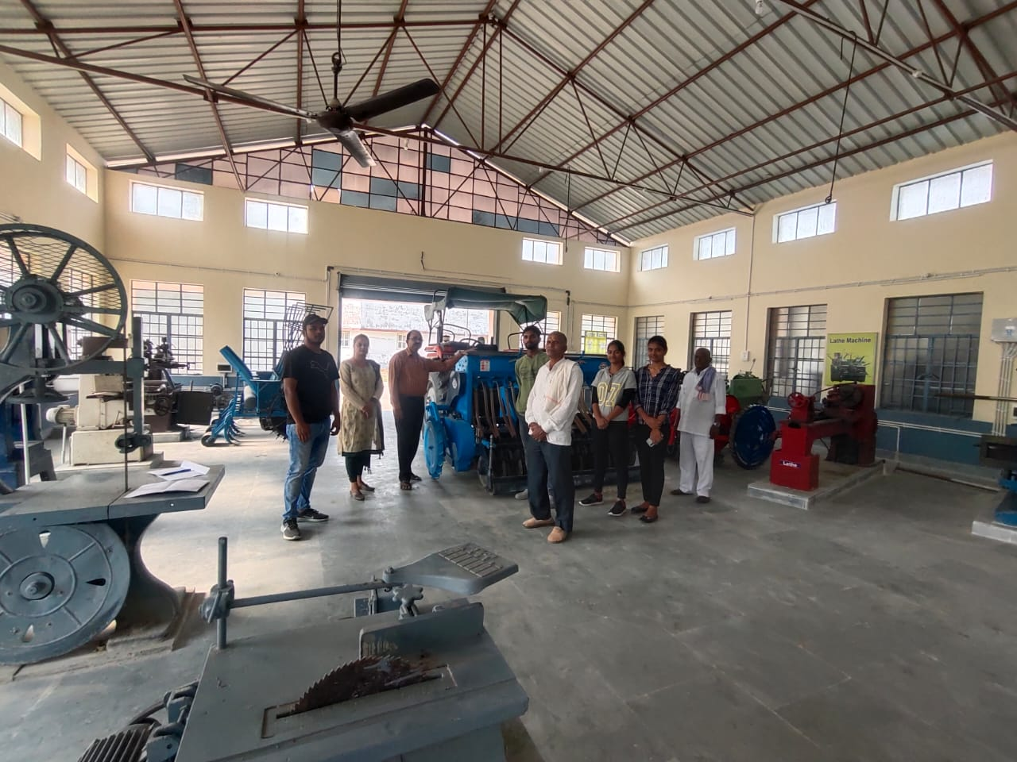

Figure 4:- farmer visit in our CHC

## CALCULATION OF HIRING PRICES FOR THE MACHINERY

**For example :- Super Seeder**

Cost value (C) = 250000

Salvage value (S) = 10% of cost value= 25000

Life (L) = 10 years

Working hours (H) = 300 hours/year

Rate of interest (i) =10% per year.

**FIXED VALUE**

Depreciation cost/ hour = (C-S)/ L*H = (250000-25000)/10*300 = 75

Interest/ hour = (C+S) *i/2H = (250000+25000)*0.1/2*300 = 45.833

Housing, interest & taxes cost= (2%) of capital cost/hour

= 0.02*250000/300 = 16.67

Total fixed cost/hour = 75+ 45.833+ 16.67=137.5

**VARIABLE VALUE**

Fuel Cost = 0

Lubricant cost = 0

Repair & maintenance cost/hour = 6% of cost value/hour

=0.06*250000/300= 50

Labour cost/hour = 300/8= 37.5

Total variable cost/hour = 50+37.5= 87.5

**Total cost/ hour=** 137.5+87.5= 225

**Operating hours/acre=** 2

**Total cost/ acre=** 225*2= 450

|  |  |  |  |  |  |
| --- | --- | --- | --- | --- | --- |
| **S. No** | **1** | **2** | **3** | **4** | **5** |
| **Machinery** | **60HP Tractor** | **Super Seeder** | **35HP Tractor** | **Multi-crop planter** | **Paddy Thresher** |
| **Cost Value** | 1000000 | 250000 | 570000 | 105000 | 12000 |
| **Salvage Value** | 100000 | 25000 | 57000 | 10500 | 1200 |
| **Years** | 10 | 10 | 10 | 10 | 8 |
| **Hours/Year** | 1000 | 300 | 1000 | 200 | 240 |
| **Depreciation** | 90 | 75 | 51.3 | 47.25 | 5.625 |
| **Interest** | 55 | 45.833 | 31.35 | 28.875 | 2.75 |
| **HIT Cost** | 20 | 16.6 | 11.4 | 10.5 | 1 |
| **Fixed Cost** | 165 | 137.5 | 94.05 | 86.625 | 9.375 |
| **Fuel Cost** | 4*94=376 | 0 | 3*94=282 | 0 | 0 |
| **Lubricant** | 376*30%=112.8 | 0 | 282*30%=84.6 | 0 | 0 |
| **Repair Cost@6%** | 60 | 50 | 34.2 | 34.2 | 3 |
| **Labour Cost** | 400/8=50 | 300/8=37.5 | 400/8=50 | 300/8=37.5 | 0 |
| **Variable Cost** | 598.8 | 87.5 | 450.8 | 71.7 | 3 |
| **Total Cost/hour** | 763.8 | 225 | 544.85 | 158.325 | 12.375 |
| **hours/acre** | 2 | 2 | 2 | 2 | 12 |
| **Total cost/ acre** | **1527.6** | **450** | **1089.7** | **316.65** | **148.5** |

Table 4:- Hiring price calculation of machineries

**CHAPTER NO. 4**

# OPERATION OF A SUSTAINABLE MODEL OF CHC

**Identify and select vendors for purchase of farm machineries and equipment.**

* Procurement would be from the approved suppliers/manufacturers.
* Suppliers should be local and in govt. Subsidy list so we can get the govt. subsidies benefit.
* Quality and safety measures must be followed.
* Customer service.
* Spare parts are easily available.
* Service centre are nearby available and easily accessible.

**Fill form and submit necessary applications to relevant government departments and obtain utilities like water, power, communications etc.**

* Water facility:- write an application to local government (Panchayat, municipalities or municipal corporations).
* Power facility:- write an application and submission of the appropriate form with proper document to power distribution company local office.
* Communication:- Network connectivity/mobile tower are already present nearby or not ,if not contact with local service centre or customer care for better connectivity. We may contact public officials and raise the issues. For other means of communication, owner contact govt. officials via a proper channel.

**State laws, shop and establishment act, taxation and labour laws.**

Different states have different laws to regulate the custom hiring centre. It is present in disintegrated manner.

## SHOP AND ESTABLISHMENT ACT

The Shop and Establishment Act is regulated by the Department of Labour and regulates premises wherein any trade, business or profession is carried out. The act not only regulates the working of commercial establishments but also societies, charitable trusts, printing establishments, educational institutions run for gain and premises in which banking, insurance, stock or share brokerage. This act regulates areas such as working hours, rest interval for employees, opening and closing hours, closed days, national and religious holidays, overtime work, rules for employment of children, annual leave, maternity leave, sickness and casual leave, etc.

## INCOME TAX

Agricultural income earned by a taxpayer in India is exempt under Section 10(1) of the Income Tax Act, 19

As per section 2(1A), agricultural income generally means:

1. Any rent or revenue derived from land which is situated in India and is used for agricultural purposes.
2. Any income derived from such land by agriculture operations including processing of agricultural produce so as to render it fit for the market or sale of such produce.
3. Any income attributable to a farm house subject to satisfaction of certain conditions specified in this regard in section 2(1A). Any income derived from saplings or seedlings grown in a nursery shall be deemed to be agricultural income.61. Agricultural income is defined under section 2(1A) of the Income-tax Act.

## LABOUR LAWS

Labour law also known as employment law is the body of laws, administrative rulings, and precedents which address the legal rights of, and restrictions on, working people and their organizations. As such, it mediates many aspects of the relationship between trade unions, employers and employees. In other words, Labour law defines the rights and obligations of workers, union members and employers in the workplace.

Generally, labour law covers:

* Industrial relations, certification of unions, labour-management relations, collective bargaining and unfair labour practices;
* Workplace health and safety;
* Employment standards, including general holidays, annual leave, working hours, unfair dismissals, minimum wage, layoff procedures and severance pay.

### Recruit workers as per the requirement.

It is mainly categorised in 3 groups:-

**(On the basis of time period)**

1. permanent worker
2. seasonal worker
3. Contractual worker

**(On the basis of skill)**

1. Skilled labour
2. semi- skilled labour
3. Unskilled labour

## Operation of CHC in a sustainable model:-

* Illustrate the procurement process of farm equipment and machinery.
* Check the quality of all received equipment from the vendor.
* Display all the machineries and equipment with in a proper manner with their name tag, function and cost of use, so farmers easily select the machineries for their crop\field.
* Monitor all the operations on the daily basis and also evaluate success or failure of business.
* Identify and report any defect and warranty in the machineries/equipment received.
* List stock spare parts for different machinery parts and prime mover.
* Update with latest farming practices, technology and use of artificial intelligence, IOT (internet of things) in agricultural implements.
* Build relationship with the target group (farmers) and engagements are most essential part of this chain.
* Prepare and expand farmer database. Database contains their (farmers) farm activity, their background, their total farm area, cropping pattern, their educational as well a financial status.
* Maintain and update MIS (management information system) on a daily basis.
* Supervise minor repair and maintenance of farm machineries and implements.
* Supervise and train the workers.
* Publish advertisement of CHC.
* Open a bank account.

**CHAPTER NO. 5**

# DOCUMENTATION AND RECORD KEEPING OF CHC

## IMPORTANCE OF DOCUMENTATION:-

* Documentation is essential to quality and process control.
* It encourages knowledge sharing, which empowers your team to understand how processes work and what finished projects typically look like.
* Effective documentation collects all of the must-know information about a task, project, or team (from account logins to step-by-step instructions) in a centralized, organized place.
* Writing down your processes is helpful for spotting any defects.
* Documentation increases the collective knowledge of everyone that you work with.
* You’ll make smarter decisions because essential information is in your hand.

## TYPES OF RECORDS:-

There are two main ways in which business records can be kept:

1. Manual record keeping.
2. Computerized (or automated) record keeping.

Examples include documents, books, paper, electronic records, photographs, videos, sound recordings, databases.

### Maintenance of documents in a customer hiring centre:-

1. For Tools
2. For equipment and machineries
3. Suppliers/ manufacturer details
4. Log book for machinery use and time
5. Records and documents for recurring cost such as:-

* Inventory cost for storage of agriculture tools, equipment & machineries.
* Fuel/ lubricant cost
* Labour charges
* Interest on bank loans
* Maintenance cost of job performed by centre.

## RECORD OF PERIODICAL MAINTENANCE OF MACHINERIES

We maintained records and documents of periodical maintenance of each tools, equipment or machinery such as utilization, performance, breakdown details, corrective actions, etc.

Here are the following records of maintenance:-

* 9/11/2022: - Potato planter was giving inaccurate plant spacing and seed rate. So, we tried to repair it. But, it was not working as per our requirement. So, we removed potato-planter from our CHC.

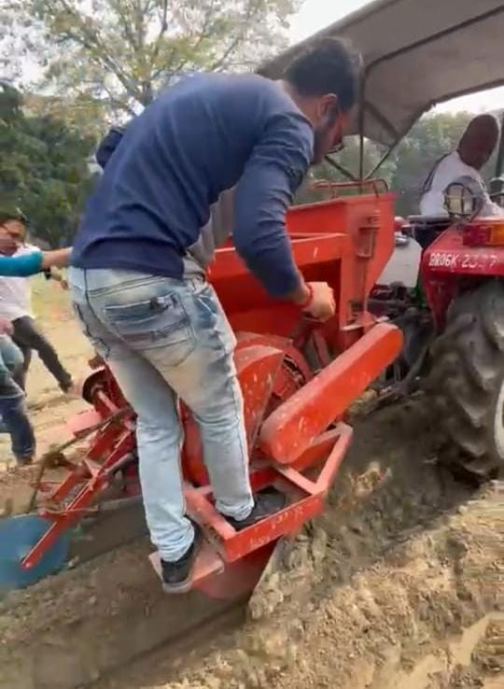

Figure 5:- Repairing of potato planter

* 10/11/2022: - Paddy thresher’s casing was being repaired and casing was greased.

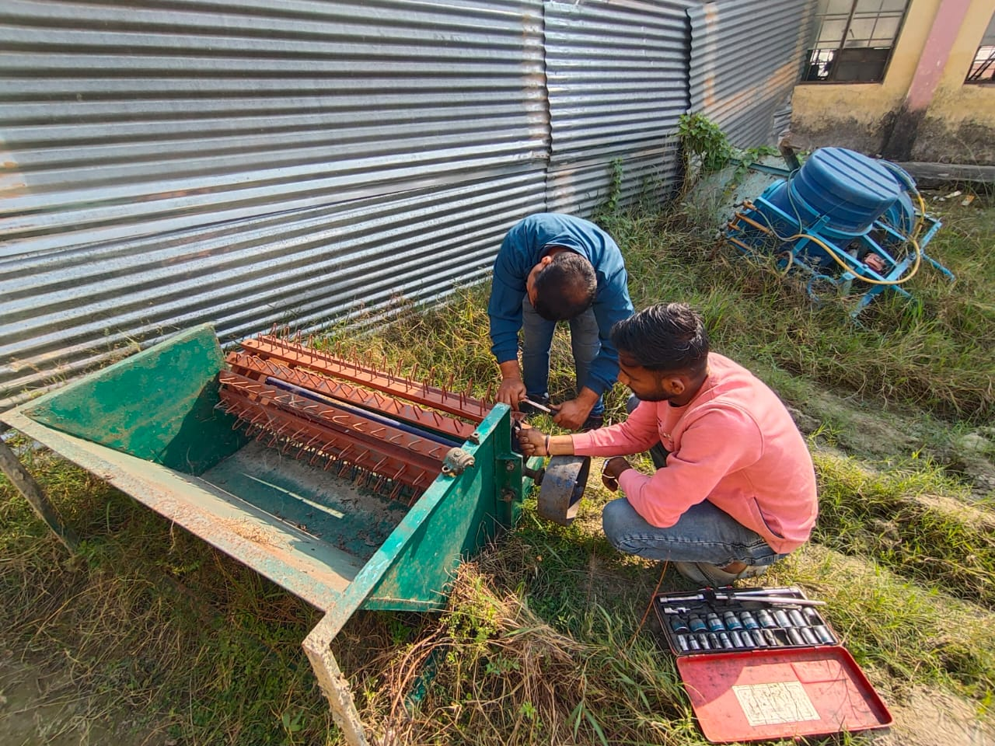 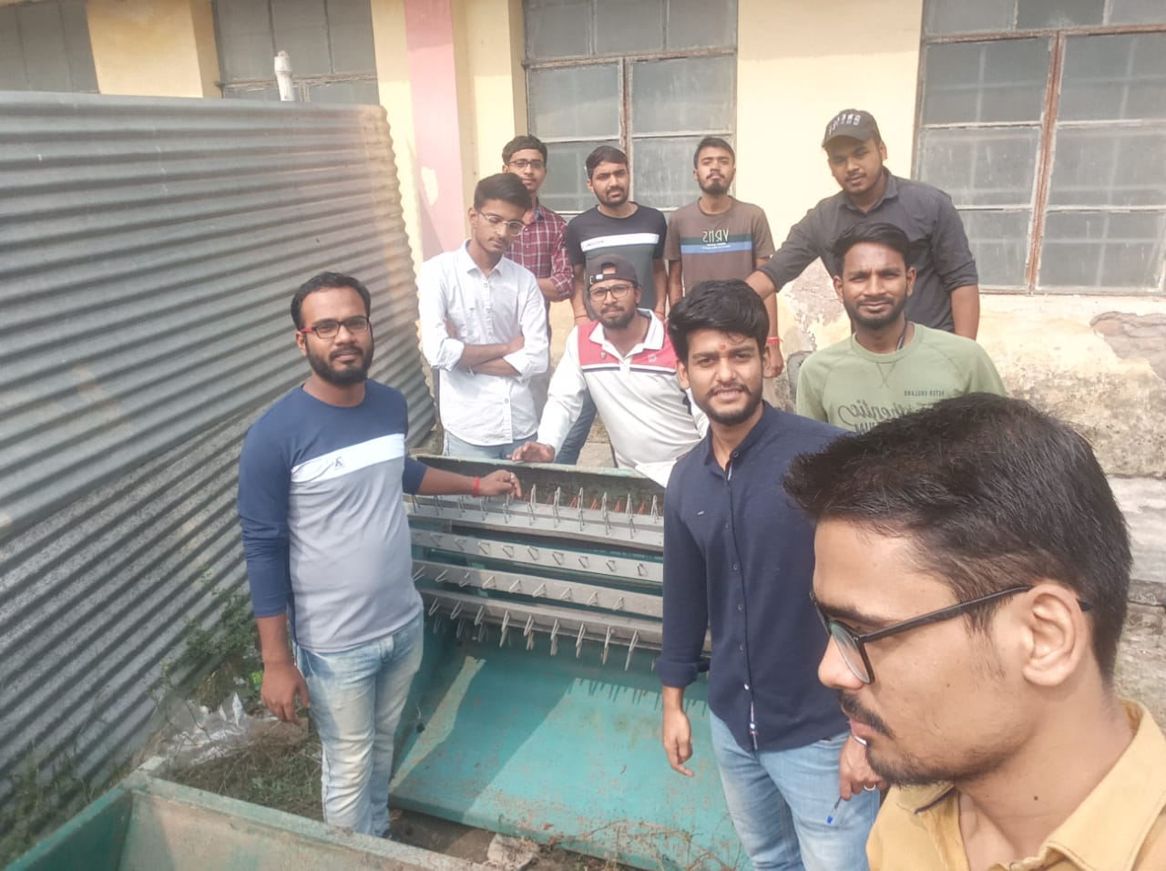

Figure 6:- Repairing of paddy thresher

* 22/11/2022: - Super seeder’s blade was broken due to operation in hard soil in Parna. So, it was repaired.

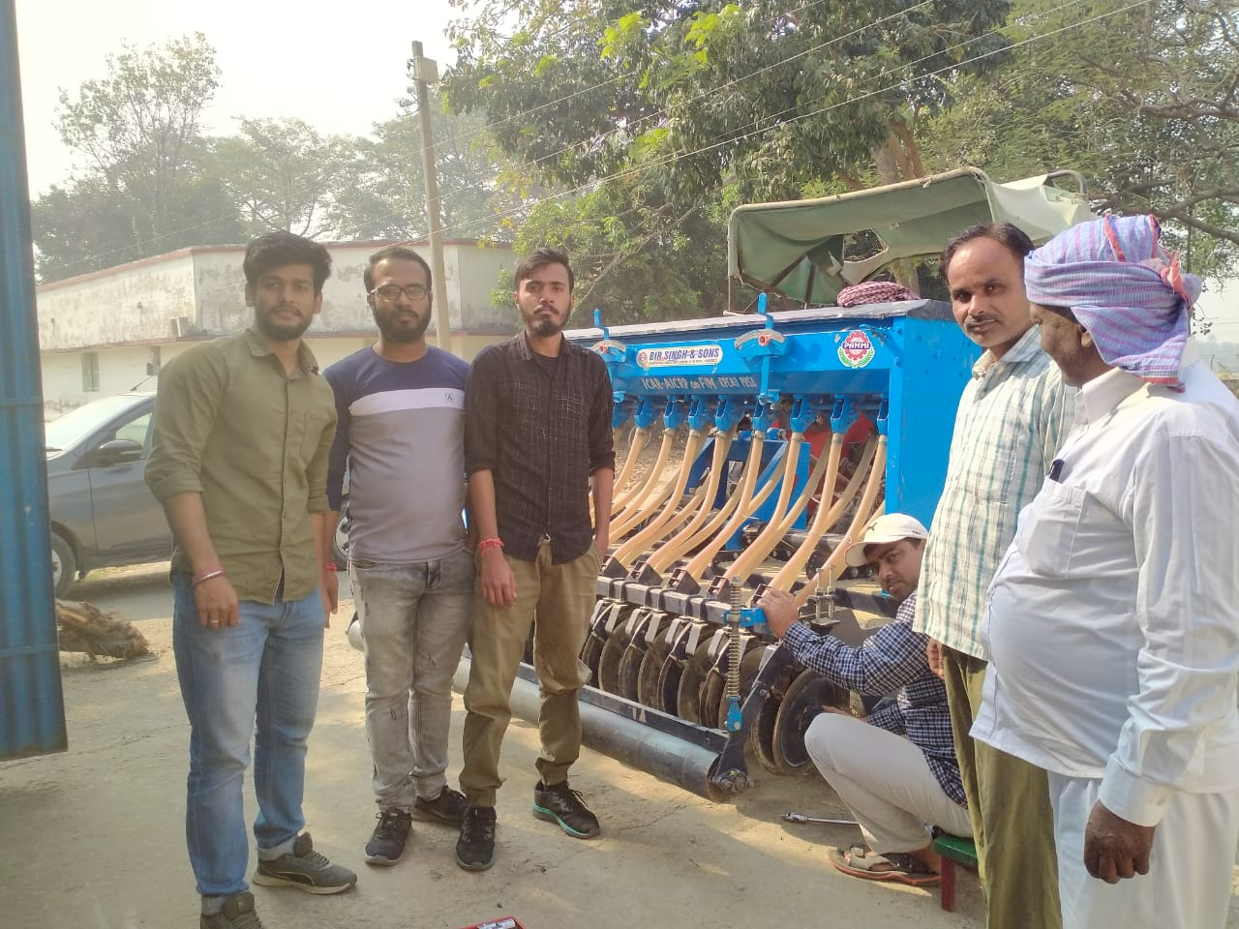

Figure 7:- Repairing of superseeder

## DATABASE OF FARMERS ALONG WITH FREQUENCY OF VISIT

|  |  |  |  |
| --- | --- | --- | --- |
| **DATE OF VISIT** | **FARMER'S NAME** | **VILLAGE** | **IMPLEMENT REQUIRED** |
| 04-11-2022 | Rajeev kumar | Harpur | Potato planter |
| 06-11-2022 | Dharmchandra rai | Bakhri | Superseeder |
| 07-11-2022 | Jaynarayan rai | Bakhri | Superseeder |
| 09-11-2022 | Vijay kumar | Deopar | Superseeder |
| 10-11-2022 | Govind singh | kothiya | Potato planter |
| 11-11-2022 | Prasun jii | punas | Potato planter |
| 15-11-2022 | Harishankar pandey | Bakhri | Superseeder |
| 16-11-2022 | Avneesh jii | Parna | Superseeder |
| 17-11-2022 | Dayashankar pandey | Parna | Superseeder |
| 18-11-2022 | Divyanshu kumar | Parna | Superseeder |
| 20-11-2022 | Awadh patel | University campus | Superseeder |
| 21-11-2022 | Vinay kr Thakur | Gorai | Paddy thresher |
| 24-11-2022 | Pashupati Pandey | Bakhri | Superseeder |
| 25-11-2022 | Arvind kr Mehta | Madhopur | Zero till drill |

## DAILY CASH RECORD

|  |  |  |  |  |  |  |  |
| --- | --- | --- | --- | --- | --- | --- | --- |
| **DATE** | **ADDRESS** | **REASON** | **AREA (ACRE) / DAY** | **INCOME** | **EXPENDiTURE** | **FUEL (litres)** | **STUDENT'S NAME** |
| 04-11-22 | KVK,Birauli | Survey | 0 | 0 | 1000 | 0 | Yogesh, Ved, Aditya, Bhukhya, Anshika, Varsha |
| 05-11-22 | Bakhri | Survey | 0 | 0 | 700 | 0 | Aditya, Ved, Anshika, Varsha |
| 09-11-22 | College | Testing (potato planter) | 0 | 0 | 200 | 0 | ALL |
| 16-11-22 | Harishankar pandey (bakhri) | Supereeder operation | 0.86 | 1425 | 700 | 15 | ALL |
| 17-11-22 | Avneesh kumar pandey (parna) | Survey | 0 | 0 | 700 | 20 | Anshika, Aditya, Varsha, Ved |
| 18-11--22 | Dayashankar prasad (parna) | Superseeder operation | 1.7 | 3060 | 700 | 15.93 | Vikas, Shashank, Yogesh, Bhukya |
| 19-11-22 | Dayashankar prasad (parna) | Superseeder operation | 0.45 | 810 | 700 | 10.5 | Devansh, Ulka, Samiran, Sankha |
| 19-11-22 | Divyanshu kumar (parna) | Superseeder operation | 0.19 | 342 | 0 | 0 | Devansh, Ulka, Samiran, Sankha |
| 21-11-22 | Awadh patel | Superseeder operation | 1.35 | 2673 | 400 | 20 | Anshika, Aditya, Varsha, Ved |
| 22-12-22 | Vinay kumar thakur | Paddy thresher | 1 day | 250 | 400 | 0 | Vikas, Shashank, Bhukya, Sankha |
| 23-12-22 | Vinay kumar thakur | Paddy thresher | 1day | 250 | 400 | 0 | Anshika, Aditya, Varsha, Ved |
| 23-12-22 | Awadh patel | Superseeder operation | 2.28 | 4514 | 400 | 15 | Devansh, Ulka, Samiran, Shashank |
| 24-12-22 | Awadh patel | Superseeder operation | 2.5 | 4950 | 400 | 10.5 | Yogesh, Shashank, Vikas, Bhukya |
| 24-12-22 | Vinay kumar thakur | Paddy thresher | 0 | 0 | 400 | 0 | Ved, Devansh, Ulka , Samiran |
| 25-12-22 | Pashupati pandey | Superseeder operation | 1.95 | 3440 | 700 | 21 | Anshika, Aditya, Varsha, Ved |
| 26-12-22 | Pashupati pandey | Superseeder operation | 1.6 | 2960 | 700 | 21 | Vikas, Ved, Shashank, Bhukya |
| 26-12-22 | Arvind kumar mehta | Zero tillage | 2 | 3200 | 1675 | 6 | Devansh, Ulka, Samiran, Aditya |
| 28-12-22 | Awadh patel | Superseeder operation | 2.4 | 4752 | 400 | 21 | Yogesh, Sankha, Bhukya, Ved |
| 29-12-22 | Awadh patel | Superseeder operation | 2.2 | 4356 | 400 | 21 | Yogesh, Sankha, Bhukya, Ulka |
| 30-12-22 | Sanjay pandey | Superseeder operation | 1.5 | 2700 | 700 | 21 | Anshika, Aditya, Varsha, Ved |
| 01-12-22 | Awadh patel | Superseeder operation | 1.29 | 2554 | 400 | 15.62 | Yogesh, Sankha, Bhukya, Shashank |
| 02-12-22 | Awadh patel | Superseeder operation | 1.02 | 2020 | 400 | 21 | Devansh, Ulka, Samiran, Aditya |
| 06-12-22 | Awadh patel | Superseeder operation | 0.98 | 1940 | 400 | 15.90 | Vikas, Shashank, Anshika, Varsha |

## BALANCE SHEET:

|  |  |
| --- | --- |
| Income | Rs. 46,196 |
| Diesel cost | Rs. 25,507 |
| Transport cost | Rs. 3,695 |
| Food cost | Rs. 12,875 |
| Testing cost | Rs. 200 |
| Expenditure | Rs. 42,277 |
| **Revenue** | Rs. 3,919 |

## FEEDBACK OF FARMERS

* **SUPERSEEDER:**
* The first farmer that visited and got ready to use superseeder was Harishankar pandey from Bakhri. He took risk for using it and after seeing the results, other farmers were reaching to our CHC.
* It should be powered by 75 hp tractor. If power is less than 75 hp, it will not be operated properly. It will take more time in transporting the implement also.
* It is better than manual broadcasting and use of cultivators.
* It is also better than zero till drill due to presence of blades like rotavator and roller.
* Saves overall sowing cost of farmers.
* Time saving and that’s why early harvesting of crops.
* There should be proper moisture in field before use of super seeder in field.
* Cropping pattern emerges out to be row wise and beautiful.
* Weeds can be managed easily.
* Mulching is done and work as organic manure.
* Proper depth and seed rate can be provided.
* Seeds are covered with soil by roller provided at back of super seeder. It reduces losses of seeds due to birds.
* **PADDY THRESHER:**
* Thresher should have transporting wheels.
* Pulley provided at side should be larger. So that speed reduction could be proper. Because, high speed of thresher had caused life dangers various time to the operator.
* Four rings should be welded as stand to support thresher and proper balancing of machine.
* There should be inbuilt motor of (2.5-3) hp power.
* **ZERO TILL DRILL:**
* They were taking risk when they thought to use zero-till drill at start. But, they were happy with later results.
* It is better than conventional sowing methods.
* It gives more yield.
* Low labour requirement.
* Time and cost saving.
* But, there is no provision for fertilizer application in machine itself.
* But, birds cause loss of seeds because they are not covered with soil.

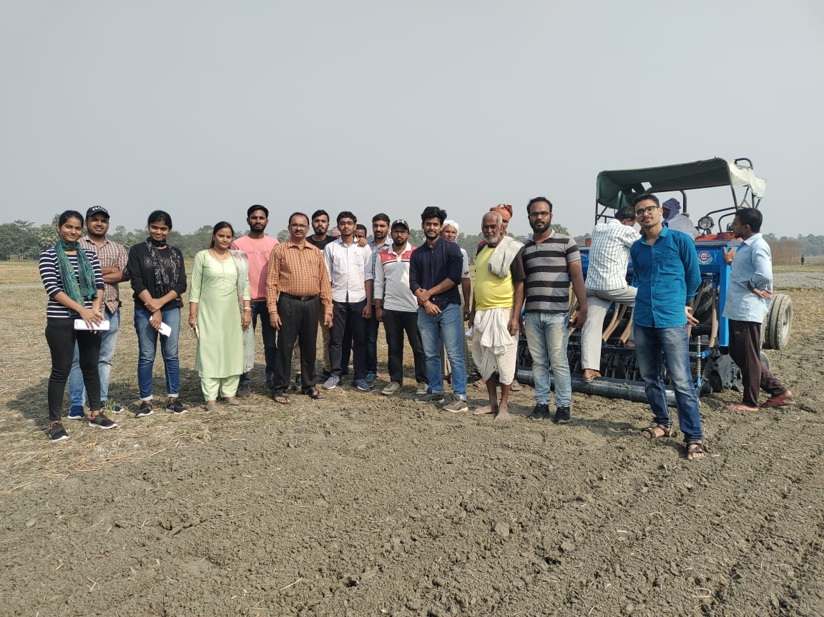

Figure 8:- First day field operation in Bakhri

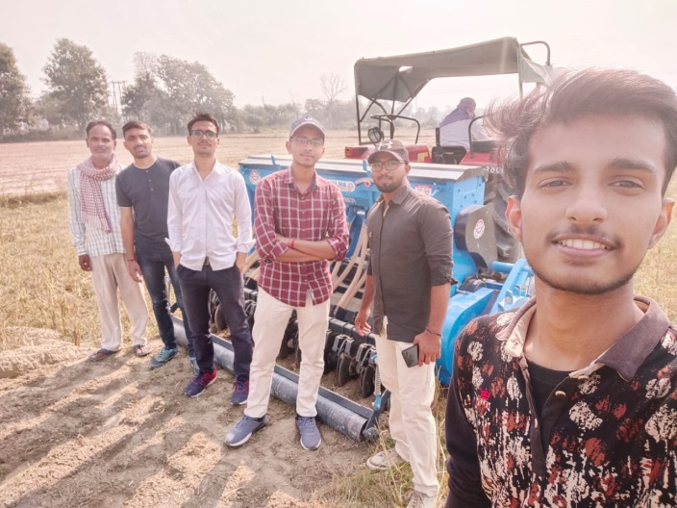 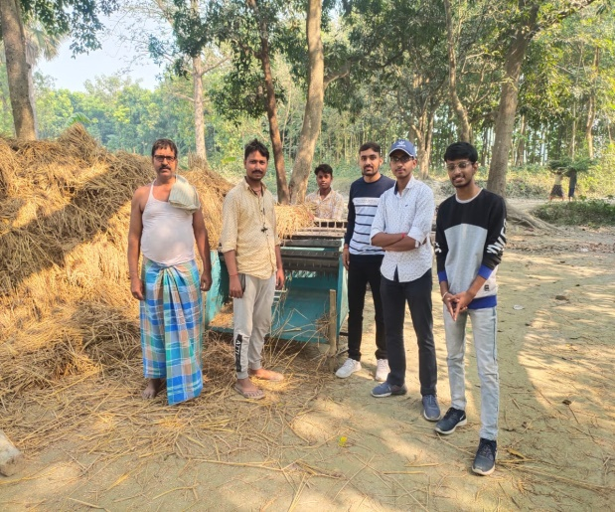

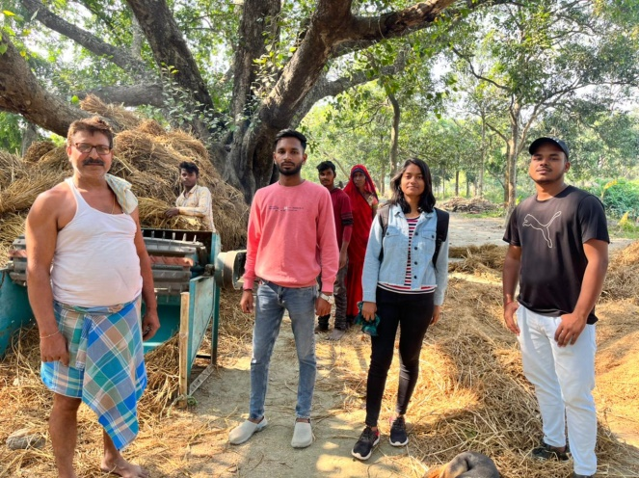 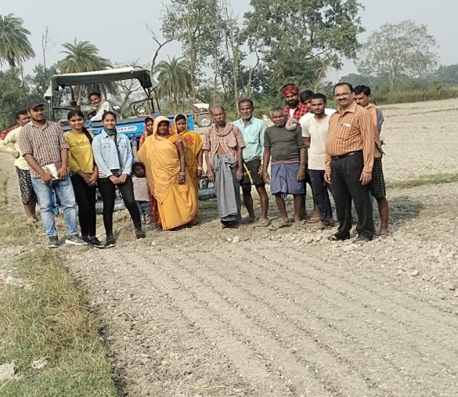

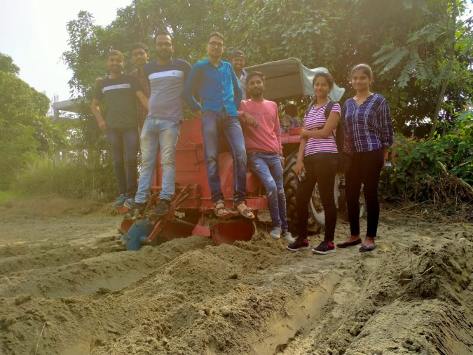 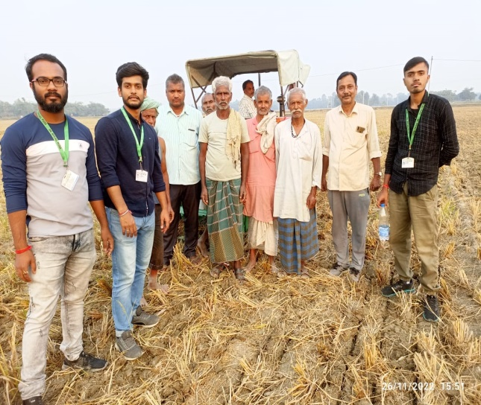

Figure 9:- FIELD OPERATION OF SUPERSEEDER AND THRESHER

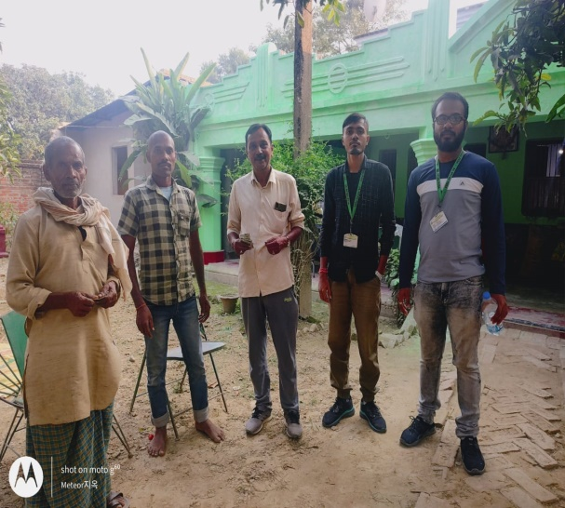 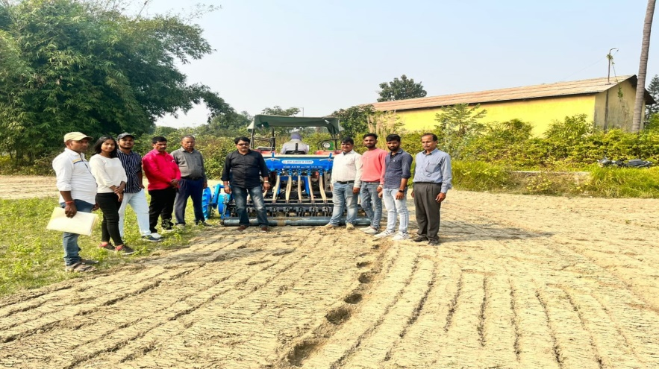

Figure 10:- CASH COLLECTION FROM FARMERS

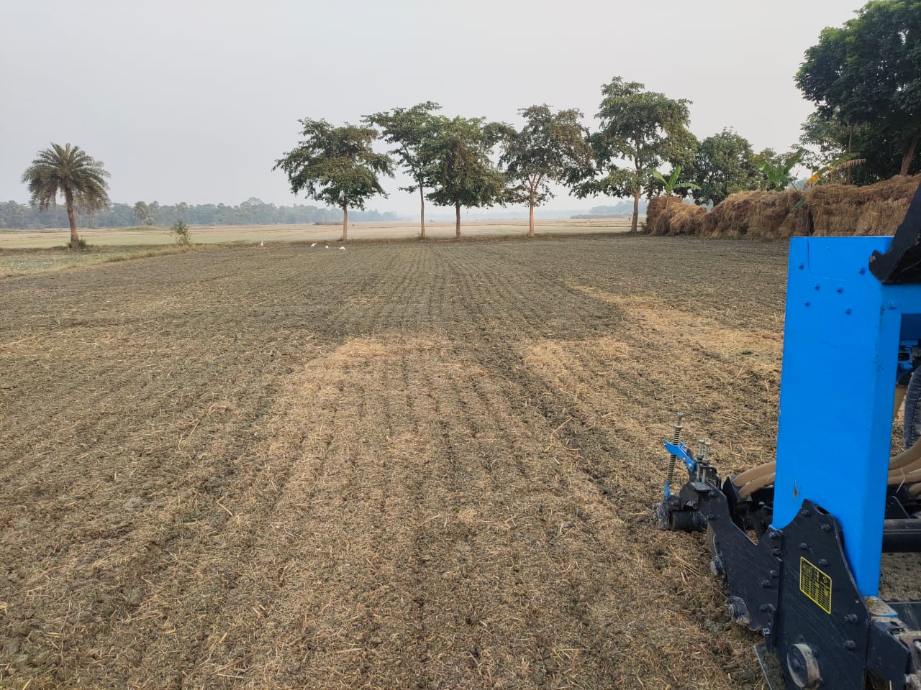

Figure 11:- FIELD DURING SUPERSEEDER OPERATION

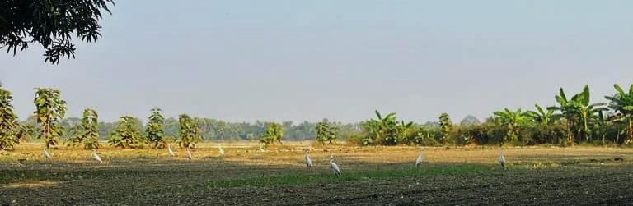

Figure 12:- FIELD AFTER 15 DAYS OF SOWING

**CHAPTER NO. 5**

# MAINTAINANCE AND SAFETY AT WORKPLACE

## BASIC SAFETY CHECKS BEFORE OPERATION OF ALL MACHINERY & VEHICLES

Machine safety is an important topic. Workplace accidents injure and sometimes kill workers. Most of these accidents need not happen if there is careful planning and awareness. Following machine safety rules are designed for the protection of employees while working around machinery:-

* Operate machinery only when safeguards are properly installed and adjusted.
* Do not use a machine with safeguards that are unauthorised or damaged.
* If you discover a machine safeguard problem, report it immediately to your supervisor.
* Lubricate machine parts wherever possible without removing the safeguard.
* Avoid creating safety hazards, e.g. new pinch points, or letting objects fall into a machine's moving parts.
* Always wear the proper protective clothing, and don't let jewellery, loose clothing or long hair dangle anywhere near machines.
* Never walk away from a machine until all its parts have stopped moving.

## PRECHECKING OF TRACTOR AND IMPLEMENTS

* Walk around tractor and check any signs of liquid leaks such as oil, coolant or fuel.
* Check the tires for wear, proper inflation and defects.
* Check the oil level by dipstick gauge.
* Check the coolant and water level in radiator.
* Check the air pre-cleaner and air cleaner.
* Check the fuel level. Fill if necessary, but at the end of the day the tractor was used.
* Check the battery terminal and electrolyte level.
* Check tension in belt.
* Check free play of clutch, steering and brake.
* Seat position and visibility of implement at back.
* Rear view mirrors.
* Slow-moving vehicle emblem.
* Lights for day or night time operation.

## PROTECTIVE CLOTHING AND EQUIPMENT

Personal protective equipment or clothing, commonly referred to as "PPE", is equipment worn to minimize exposure to hazards that cause serious workplace injuries and illnesses. These injuries and illnesses may result from contact with chemical, radiological, physical, electrical, mechanical, or other workplace hazards. Personal protective equipment may include items such as gloves, safety glasses and shoes, earplugs or muffs, hard hats, respirators, or coveralls, vests and full body suits.

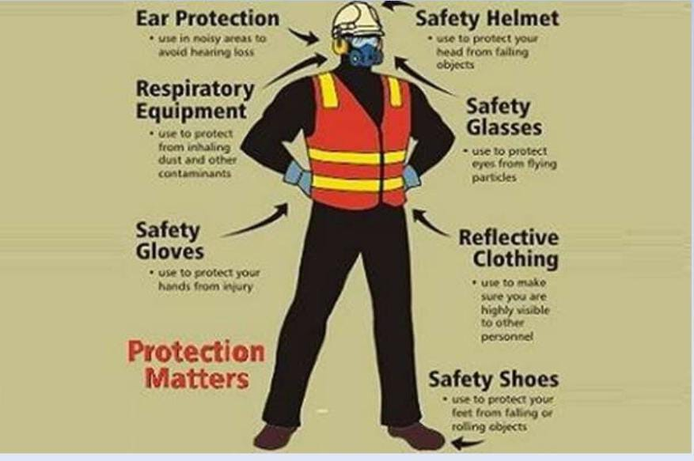

## HAZARDS MENTIONED ON THE LABELS OF PESTICIDES/ FUMIGANTS

* Child Hazard Warning Statement
* Precautionary Statements
* First Aid Statement
* Personal Protective Equipment (PPE)
* Storage and Disposal

**It is important to understand the meaning of three different types of statements on the pesticide label.**

* Mandatory Statements

●“Wash application equipment”

●“Wear chemical-resistant gloves”

●“Keep away from heat, sparks, and open flame”

●“Do not enter treated area for 12 hours”

●“Use medium or larger spray droplets”

* Advisory Statements

●“Barrier laminate gloves provide the best protection”

* Factual Statements

●These are neither mandatory nor advisory.

●“Harmful if inhaled”

## OTHER REGULATIONS AT CHC:-

* Assess risks prior to performing manual handling jobs and work according to currently recommended safe practices.
* Use equipment and materials safely and correctly and returns the same to designated storage when not in use.
* Dispose of waste safely and correctly in a designated area.
* Assess environmental damage with work like:- air and noise pollution and other hazards.
* Identify accidents, fires and emergencies, reporting procedure and measure.
* Use emergency equipment in accordance with manufactures’ specification and workplace requirements.
* Administer first aid.